**7042 Final Project**

**Group Members:** Morgan Miller, Sidney Schaeper, Paulo Soto

**Grade Sheet**

Complete this grade sheet and submit it on Blackboard.  For items that you have fully completed, assign yourself 10/10.  For partially complete items, assign something between 6 and 9 out of 10, depending on the level complete. For incomplete items, assign 5/10.  Note: If you give yourself a 10/10 for something that is not 100% complete, I will assign 0/10.

General

0)      Submitted on time.  If not, # of days late __0__   * -10% for each day late: __0__

1)      Code is in good form. It is readable and tabbed appropriately.  _10_/10

2)      Did something extra, beyond the minimum requirements stated here.  _10_/10

What, specifically, did you do?  You must complete this to get credit.

________________________We used 3 separate JSON streams. We did two different streams from Yelp and joined them and consumed a third JSON from another group about Business Licenses. Additionally utilized javaScript to change our numeric rating values into stars._______________________________________

Version Control

3) This project is posted on GitHub.uc.edu.  All team members have made commits.  _10_/10

Github URL: <https://github.com/PauloCSoto/BreweryRatings>

4)You implemented another group’s code review recommendations: _10_/10

Which ones did you implement?  You MUST complete this section to get credit.

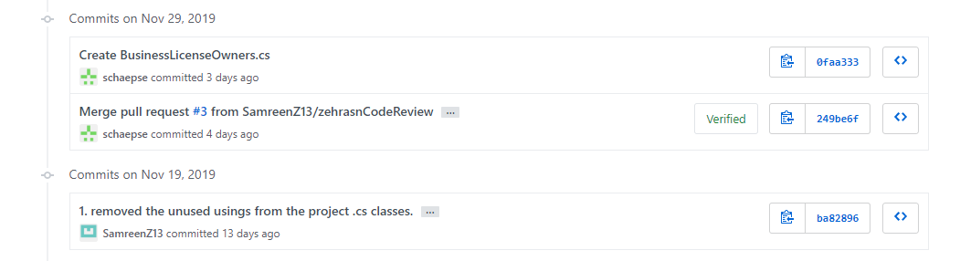

Project

5) Publicly hosted in Azure.  _10_/10

What is the public URL?  Must complete this to get credit: ___________<https://breweryratings20191109050130.azurewebsites.net/>________

6) Consume at least two JSON services; one publicly available, and one from a fellow student group. _10_/10

7) Show results of JSON service data in a human-readable, HTML + CSS format.  _10_/10

8) Produce data via REST/JSON, along with an OpenAPI or JSON Schema file.  _10_/10

9) Gather data from the user via a form or other means.  _10_/10

10) Site looks good, uses CSS, images, and theme colors for consistent styling. HTML conforms to XHMTL 1.0 strict _8_/10

We validated our code for our cshtml pages based on the html and CSS code we had written. When checking the source of the entire site there are errors due to the “_Layout.cshtml” page that was pregenerated by the Web Application ASP.NET formatting in MS Visual Studio.